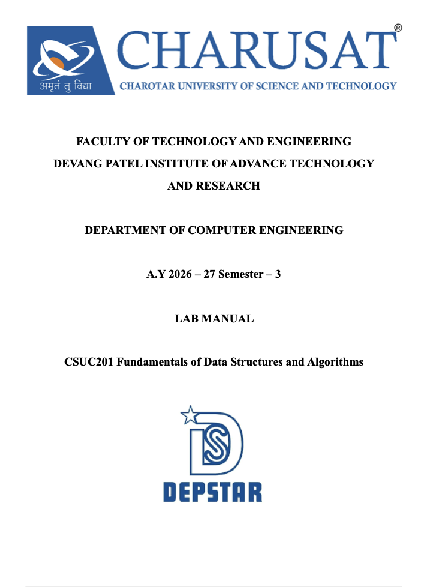Practical 7: Queue Implementation using Array and Linked
List, with Structure Simulation

Practical Aim
To implement queue using array and linked list, and apply queue-based logic to number
generation, and structure simulation problems.

Problem 1:
A government office has a token counter that issues tokens to visitors. The counter can hold at most n tokens at a time. New visitors join from one end and are served from the other end in the order they arrived. If the counter is full, no new token can be issued, and if it is empty, no one can be served. Given a sequence of join and serve operations, implement this fixed-capacity token system and print the current front token after each operation. Report an error if an operation cannot be performed.Describe how your solution tracks the front and rear of the queue. What happens to your front and rear pointers over time as join and serve operations keep happening, and does your solution handle the case where space appears to run out even though slots have been freed?

For code :

https://github.com/kvvaghasiya49/FDSA/tree/6fb2f463bf1f58ac 408ada5ca8ffdaa64bc82087/DSA

Output:
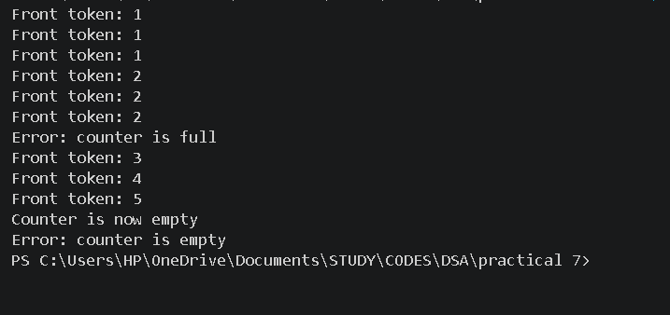

Problem 2
A hospital emergency ward receives patients continuously and attends to them strictly in the order they arrived, with no upper limit on how many can be waiting at once. New patients are added at the back and the doctor always attends to the patient at the front. Given a sequence of arrive and attend operations, implement this unlimited patient queue and print the current front patient after each operation.Describe how your solution differs from Problem 1 in how it manages capacity. What happens in your solution when the attend operation is called on an empty ward with no patients waiting?

For code :

https://github.com/kvvaghasiya49/FDSA/tree/6fb2f463bf1f58ac 408ada5ca8ffdaa64bc82087/DSA

Output:

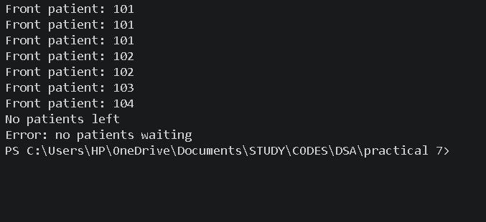

Challenges Faced:
In the array queue, the hardest part was tracking the front and rear pointers. Every join moves the rear forward and every serve moves the front forward, so the pointers only move in one direction. After many operations, the rear reached the end of the array and the queue said it was full, even though there were free slots at the front. This confused me at first, because the queue was not really full. I also had to check rear == n-1 before a join and front > rear (or an empty condition) before a serve, otherwise the program wrote outside the array or served a token that did not exist.

Learning Outcomes:
- I learned how to build a queue using an array with a fixed size and using a linked list with no fixed size.
- I understood that a queue works on the first-in first-out idea, where joining happens at the rear and serving happens at the front.
- I learned that a simple array queue can show "full" even when slots are free, and that a circular array fixes this by wrapping the pointers using modulo.
- I learned that when the last node is removed from a linked list queue, both front and rear must be updated, not only front.

Key Questions / Analysis / Interpretation to be Evaluated During/After
Implementation:

- [Problem 1] A simple array queue eventually reports being full even when slots have been freed at the front. Explain why this happens structurally — not by tracing an example, but by describing what the front and rear pointers represent and what their movement pattern causes over time.

Ans: front points to the first element, while rear points to the next position where an element is inserted.As both move only forward, freed spaces at the front are not reused, so rear eventually reaches the array’s end and the queue appears full.

- [Problem 2] Your linked list queue has no capacity limit. If arrive operations vastly outnumber attend operations over a long period, what real consequence would this have on the system, and where in your code is that consequence invisible?

Ans: If arrivals greatly exceed attend operations, the linked list keeps growing and consumes more and more memory, possibly causing memory exhaustion.

